TYPE-2 Hyper visor:

1. Below is the screenshot of running Qemu on kali.

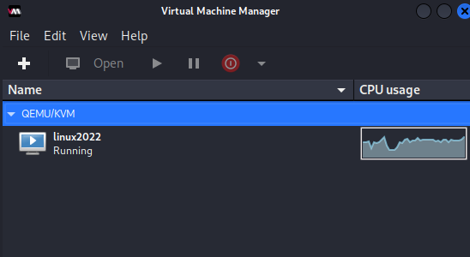

1. Report:
   1. I’m using kali Linux for installing Hypervisor.
   2. I have been using Kali Linux for last 5-6yrs inside virtual machine or dual booting it with windows.
   3. I’m using QEMU hypervisor. To learn how to use hypervisor on Linux. I have used Virtual and vmware on windows and Mac and reason for using it now is learn using virtual machine in Linux.
   4. Installing qemu for first time on kali.

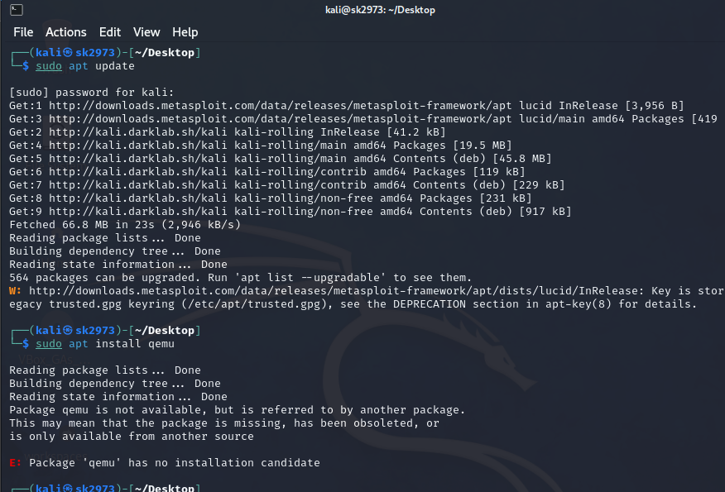

As you can see the in the screenshot qemu is not directly available.

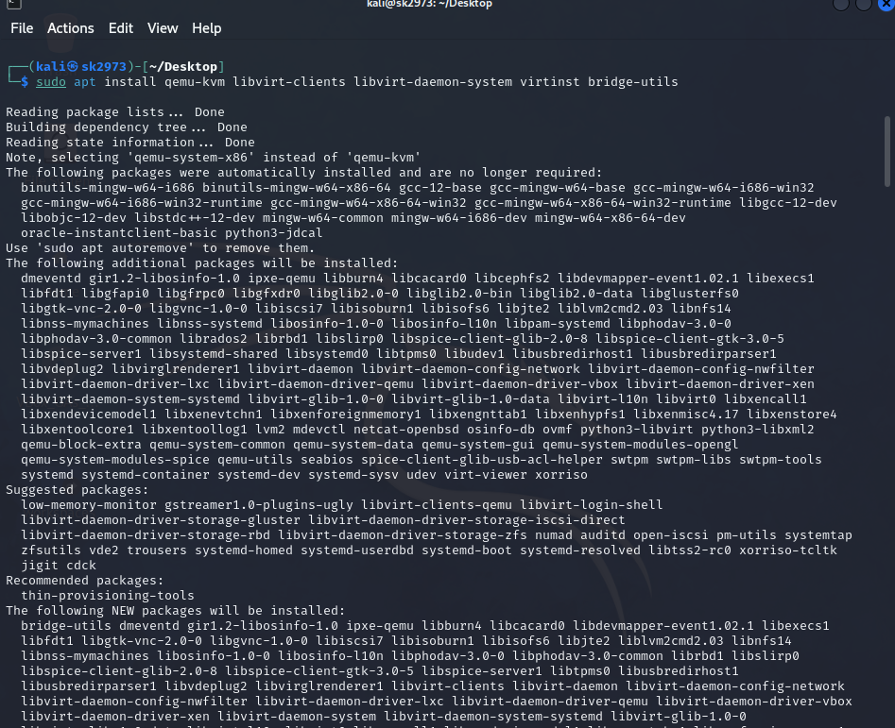

This is the correct command for installing qemu in linux.

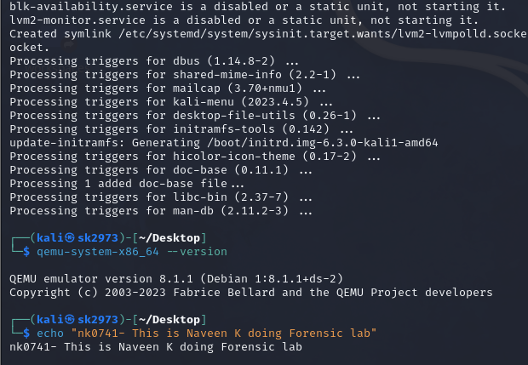

We have installed version 8.1.1 of QEMU in kali.

1. The commands for installing qemu are different than installing another software.

* We can only use the command line version of qemu but if we need the gui verison.
* We need to run the following command: “sudo apt update && sudo apt install virt-manager -y” and next “virt-manager” command to access the gui version.

1. I think we can install qemu by downloading the .tar.gz and running it. We can also try to use the command line version as well.
2. I think it’s not easy for new users to use and understand. They can start with the windows version of hypervisor as they have better gui and are easy to use. They can follow youtube videos to understand it.  
     
   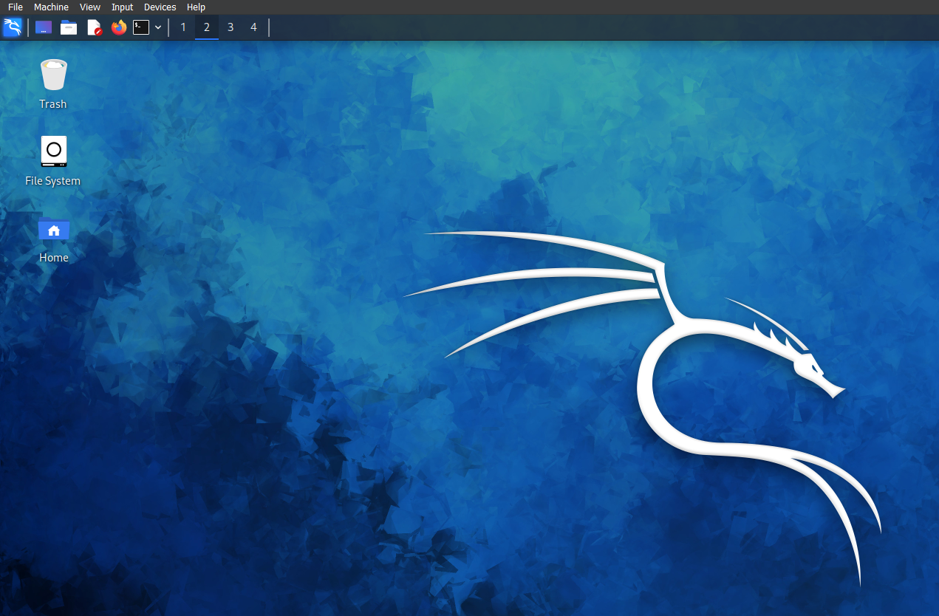
3. After installing the vm inside qemu.